
WEEK-7
AIM: Design a form with various input fields.

DESCRIPTION: In this tinkering activity, a form is designed with various input fields such as text boxes, radio buttons, checkboxes, dropdowns, and submit buttons. The goal is to explore how user input can be collected and processed through an interactive interface. This experiment helps understand basic UI design, data collection, and form validation concepts, encouraging creativity and problem-solving in building user-friendly digital forms.

PROGRAM:
import 'package:flutter/material.dart';
void main() => runApp(MaterialApp(home: SimpleForm())); class SimpleForm extends StatefulWidget {
@override
_SimpleFormState createState() => _SimpleFormState();
}

class _SimpleFormState extends State<SimpleForm> { final _formKey = GlobalKey<FormState>();
String name = ''; String email = ''; String password = ''; String gender = 'Male'; bool accepted = false;
final genders = ['Male', 'Female', 'Other']; @override
Widget build(BuildContext context) { return Scaffold(
appBar: AppBar(title: Text('Simple Form')), body: Padding(
padding: EdgeInsets.all(16), child: Form(
key: _formKey, child: ListView( children: [
TextFormField(
decoration: InputDecoration(labelText: 'Name'), onSaved: (val) => name = val ?? '',
validator: (val) => val!.isEmpty ? 'Enter name' : null,
),
TextFormField(
decoration: InputDecoration(labelText: 'Email'), keyboardType: TextInputType.emailAddress, onSaved: (val) => email = val ?? '',
validator: (val) => val!.contains('@') ? null : 'Enter valid email',
),

TextFormField(
decoration: InputDecoration(labelText: 'Password'), obscureText: true,
onSaved: (val) => password = val ?? '',
validator: (val) => val!.length < 6 ? 'Min 6 characters' : null,
),
DropdownButtonFormField<String>( value: gender,
items: genders
.map<DropdownMenuItem<String>>(
(g) => DropdownMenuItem<String>( value: g,
child: Text(g),
))
.toList(),
onChanged: (String? val) => setState(() => gender = val ?? 'Male'), decoration: InputDecoration(labelText: 'Gender'),
),
CheckboxListTile(
title: Text('Accept Terms'), value: accepted,
onChanged: (bool? val) => setState(() => accepted = val ?? false),
),
ElevatedButton( child: Text('Submit'), onPressed: () {
if (_formKey.currentState!.validate() && accepted) {
_formKey.currentState!.save(); showDialog(
context: context,
builder: (_) => AlertDialog( title: Text('Form Submitted'), content: Text(
'Name: $name\nEmail: $email\nGender: $gender'),
),
);
} else if (!accepted) { ScaffoldMessenger.of(context).showSnackBar( SnackBar(content: Text('Please accept terms')),
);
}
},
),
],
),
),
),
);
}
}

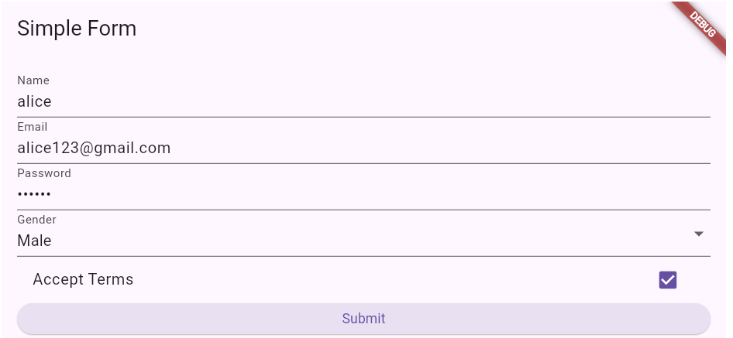
OUTPUT:
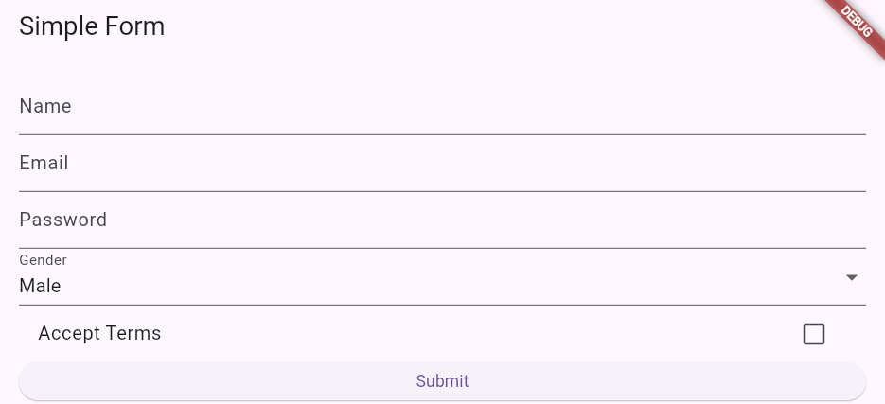

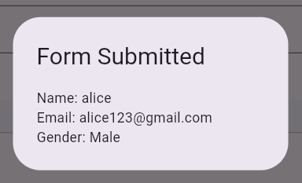

B) AIM: Implement input validation and error messages using Form and validator

DESCRIPTION: In this tinkering activity, a Flutter Form is created with multiple input fields that include validation and error messages using the Form widget and validator functions. Each field checks for specific input rules, such as non-empty names, valid email formats, and minimum password length. If inputs are invalid, real-time error messages guide users to correct them. This helps learners understand form validation, user feedback, and data reliability in app development.

PROGRAM:
import 'package:flutter/material.dart';
void main() => runApp(MaterialApp(home: ValidationForm())); class ValidationForm extends StatefulWidget {
@override
_ValidationFormState createState() => _ValidationFormState();
}

class _ValidationFormState extends State<ValidationForm> { final _formKey = GlobalKey<FormState>();
String email = ''; String password = '';

@override
Widget build(BuildContext context) { return Scaffold(
appBar: AppBar(title: Text('Validation Form')), body: Padding(
padding: EdgeInsets.all(16), child: Form(
key: _formKey, child: Column( children: [
// Email input with validator TextFormField(
decoration: InputDecoration(labelText: 'Email'), keyboardType: TextInputType.emailAddress, validator: (val) {
if (val == null || val.isEmpty) return 'Email is required.'; if (!val.contains('@')) return 'Enter a valid email.'; return null;
},
onSaved: (val) => email = val ?? '',
),
SizedBox(height: 16),

// Password input with validator TextFormField(
decoration: InputDecoration(labelText: 'Password'),

obscureText: true, validator: (val) {
if (val == null || val.isEmpty) return 'Password is required.';
if (val.length < 6) return 'Password must be at least 6 characters.'; return null;
},
onSaved: (val) => password = val ?? '',
),
SizedBox(height: 24),

ElevatedButton( child: Text('Submit'), onPressed: () {
if (_formKey.currentState!.validate()) {
// If valid, save the form fields
_formKey.currentState!.save(); showDialog(
context: context,
builder: (_) => AlertDialog( title: Text('Success'),
content: Text('Email: $email\nPassword: $password'),
),
);
}
},
),
],
),
),
),
);
}
}

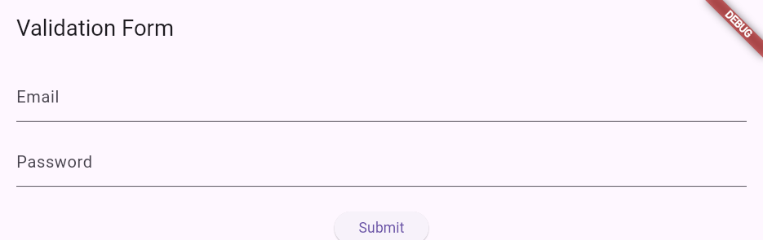
OUTPUT:


